**College Feedback System**

* The system is designed to give feedback on how the college staff members are performing as well as the college as a whole.
* The system is designed to carter for student forms.

**Technology behind the System**

I used:

1. HTML5
2. CSS3
3. Bootstrap 4
4. JavaScript (Vanilla) and its framework JQuery
5. Flask for backend and server
6. MySQL Database (MariaDB)
7. Some npm packages (tabulator)

**System Requirements:**

This system runs on pc with:

* Python 3.6 and above
* Flask
* MySQL database
* Ram minimum of 1gb
* Drive space minimum of 10gb
* Operating Systems Windows 7 and better

**HOW DOES THE SYSTEM WORKS**

The system architecture works by giving the admin all privileges to the system.

The admin is the only person who can see what students has posted.

He can see this information in terms of a table that shows the data according to average rating.

The second user of the system is the student. The student is the 3rd user who has right over his/ her account only.

On registration the student uses a username as a way to provide anonymity when the admin reveals data of the system.

One of the terms of the system is “To not use any vulgar word in comment bars”. The admin is able to see who ever posted an explicit word in the system but still the privacy of the system is still intact.

The student is only able to post one form in the system

HOME PAGE OF SYSTEM

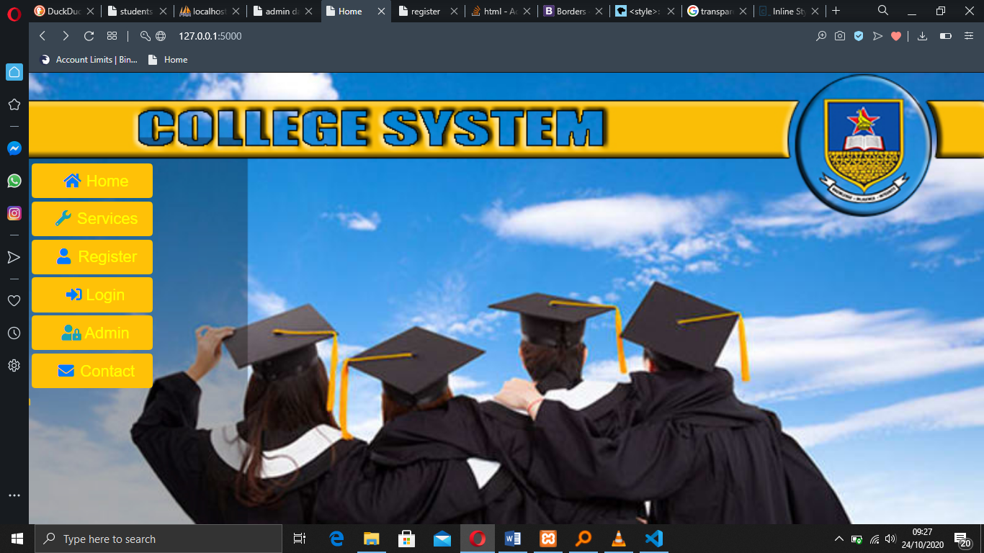

REGISTRATION PAGE

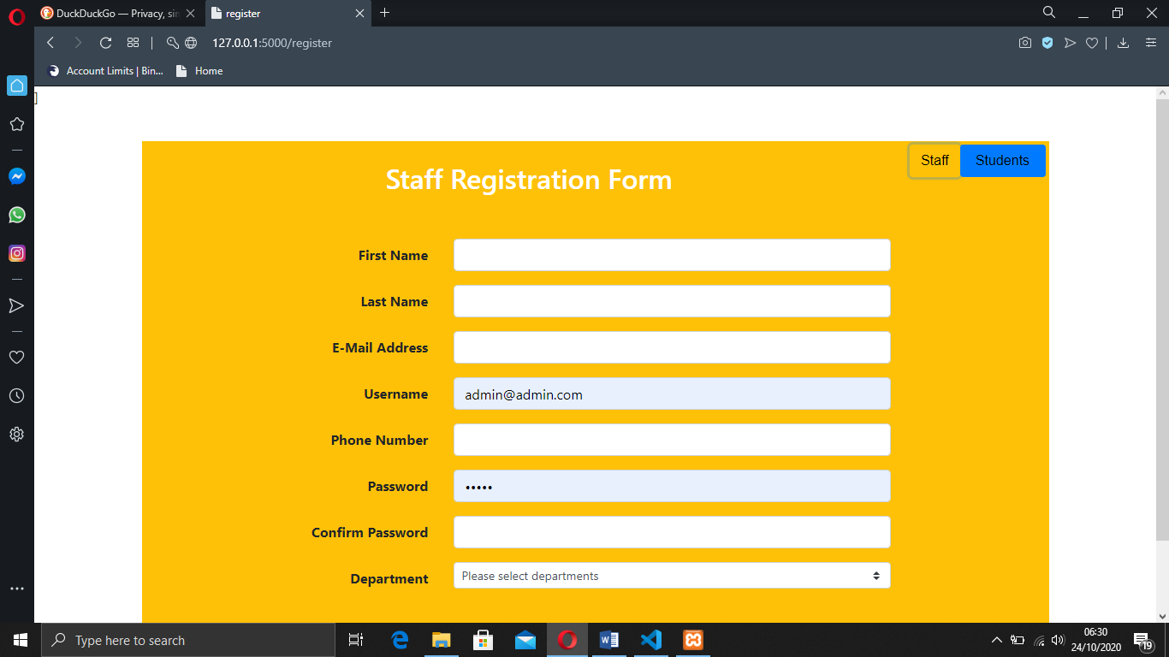

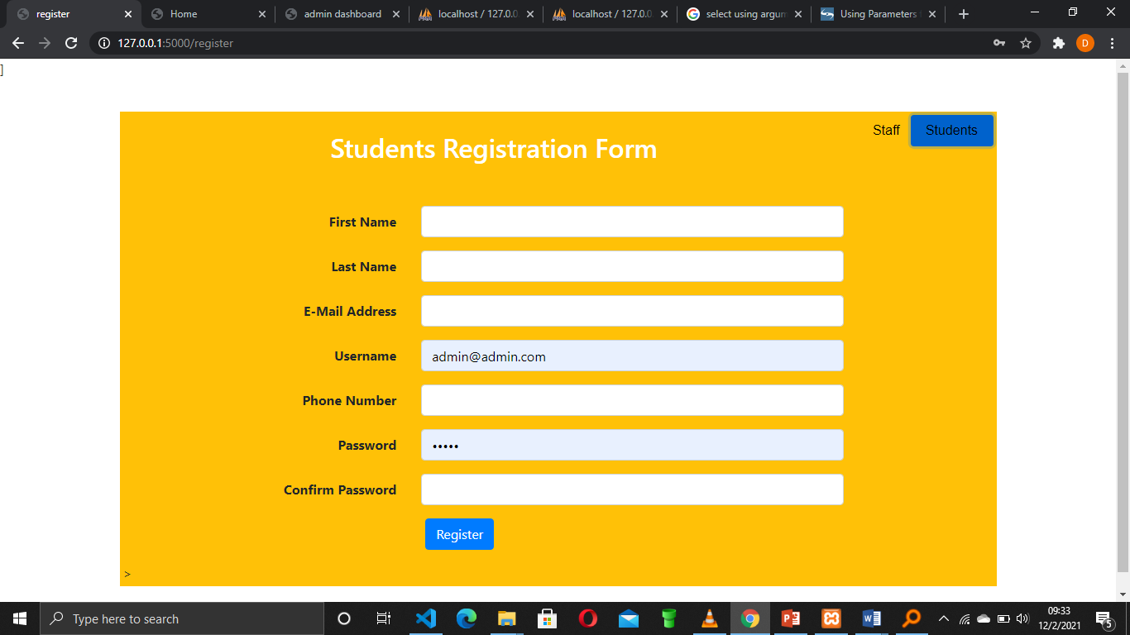

The registration page comes with a switch to switch between 2 forms for staff and for students.

The selection for departments is manipulated by the admin who can add new departments into the system.

LOGIN

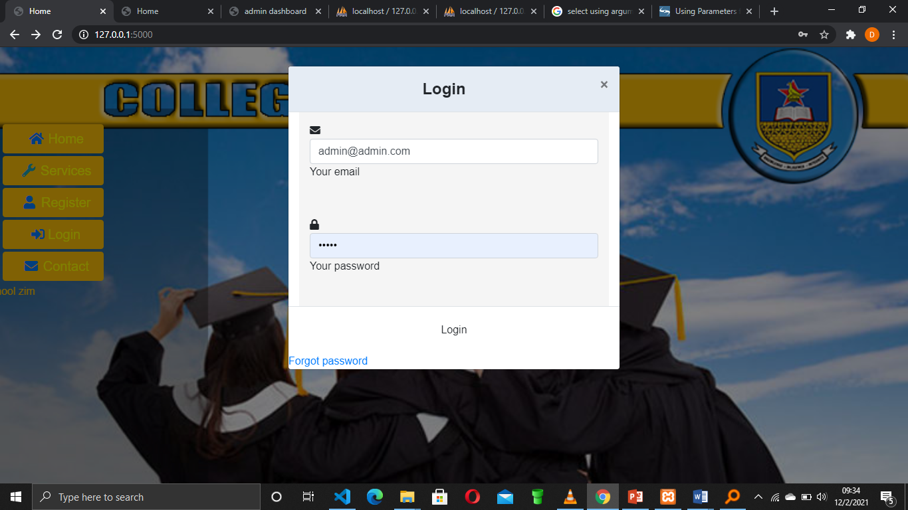

For login I used Bootstrap modal. This is to eliminate response time to and from server requesting the page.

The login feature carter for all 3 (staff, admin and students) and it auto navigates to a required page.

THE STUDENTS DASHBOARD

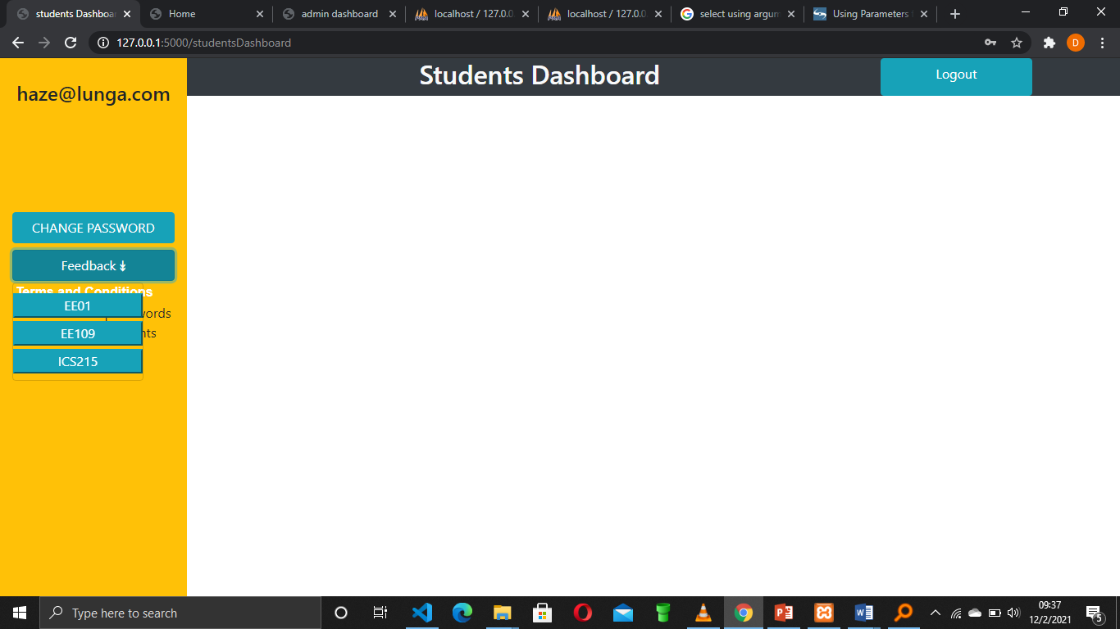

The student dashboard has a dropdown to select which module one want to provide feedback for.

After selecting the module the modal for the module will be lifted to provide feedback.

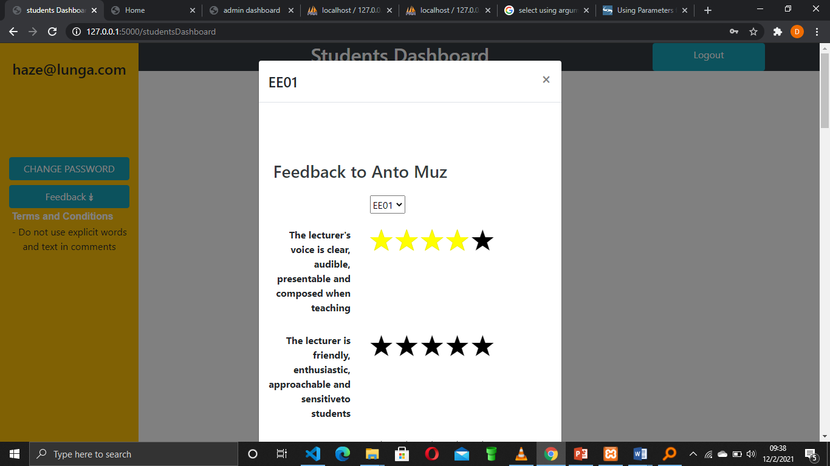

The students dashboard uses rating stars to rate both staff and college

The first section of the form gives rating on staff and the comment on that section is on the staff.

You write one of your lecturers you would like to give feedback on.

The second section is on school as a whole

**ADMIN DASHBOARD**

The admin has the ability to see who has posted the feedback and only under the modules.

The admin has the ability to see the staff that received the feedbacks and how many they received.

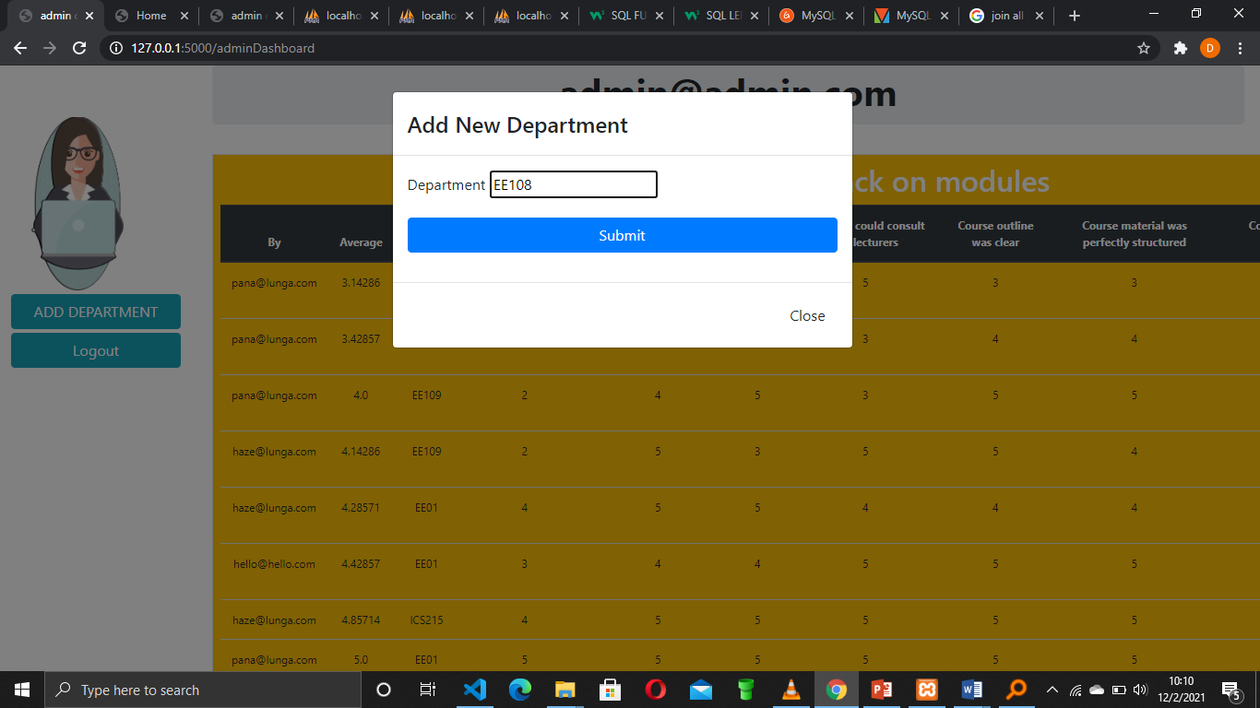

The admin can add new department which can be added to the registration page for both students and staff.

The admin can also see the two tables where first one college feedback and second for staff feedback.

**PROBLEMS ENCOUNTERED WHEN DESIGNING THE SYSTEM**

I didn’t have enough time to implement all the features I wanted to implement eg

The staff can see how he or she is performing based on students rating.

Time to design for mobile versions.

Testing of product.

UNIT TESTING

I conducted a unit test to test the individual components of the system.

I tested database for redundancy, delete anomaly, insert anomaly and update anomalies.

I tested the UI for feedback mechanism.

**Results**

The system passed the unit testing.

INTEGRATION TESTING

After testing individual components, I conducted an integration test to check if the system components are cohesive enough to work together.

Combining the system modules was a challenge but because of the architecture I used to design the system it worked at last.

I used a monolithic architecture.

System Testing

Last testing I did was a system test to test if the system works on other versions. It passed on windows 7-10 without failure as long as the system can support python 3.6 and better as well as it has the system requirements started above.

Beta testing was done as a way to check the friendliness of the system. User experience turned out to be perfect and easy to navigate.